Installing and Configuring Oracle GoldenGate Monitor 12c (12.2.1) -sjprgldngtmon01

Table of Contents

Step1 Preparing to Install 2

1.1 Install NX 2

1.2 Create oracle account: 2

1.3 For installation, we need remove noexec from /tmp 2

1.4 vi /etc/security/limits.conf 2

1.5 vi /etc/sysctl.conf 3

1.6 vi .bash_profile: 3

1.7 Related Port: 3

1.8 Need download software: 3

Step2 Install Oracle WebLogic Server 12c (12.2.1) 5

Step3 Install Oracle Goldengate Monitor: 13

Step4 Creating a Repository 19

Step5 Configure domain 32

Step6 Create oggadmin account: 47

Step7 Configure start and stop Admin server and Monitor server without password: 48

Step8 Configure start and stop Admin server and Monitor server script: 49

Step9 Completing Monitor Server Configuration 52

Step10 Configure agent: 53

Step 11 SiteOps to configure monitor on the sjprgldngtmon01 54

# Step1 Preparing to Install

# Install NX

# Create oracle account:

oracle account: group dba and oinstall

# For installation, we need remove noexec from /tmp

Check /etc/fstab:

/dev/mapper/vg_00-lv_tmp /tmp ext4 rw,noexec,nodev,nosuid 1 2

Modify to:

/dev/mapper/vg_00-lv_tmp /tmp ext4 rw,nodev,nosuid 1 2

restart

# vi /etc/security/limits.conf

oracle hard nofile 65536

oracle hard nproc 16384

oracle soft nofile 4096

oracle soft nproc 2047

oracle soft memlock 24051816

oracle hard memlock 24051816

oracle soft core unlimited

root hard nofile 65536

root hard nproc 16384

root soft nofile 4096

root soft nproc 2047

root soft memlock 24051816

root hard memlock 24051816

root soft core unlimited

# vi /etc/sysctl.conf

kernel.shmmax = 6442450944

/sbin/sysctl -p

# vi .bash_profile:

export PS1='`hostname -s` [`whoami`] > '

export ORACLE_BASE=/u01/app/oracle

export ORACLE_HOME=/u01/app/oracle/product/12.2.0/middleware_12.2.1.2.0

export JAVA_HOME=/usr/java/default

export LD_LIBRARY_PATH=$ORACLE_HOME:$ORACLE_HOME/lib:$LD_LIBRARY_PATH

export PATH=$PATH:/sbin:/usr/local/bin:.:/home/oracle/asm:/u01/app/oracle/script

export PATH=$PATH:$JAVA_HOME/bin:/sbin:/usr/local/bin:.:/home/oracle/asm:/u01/app/oracle/script

export FMW_HOME=/u01/app/oracle/oggmon12.2.0_domain

# Related Port:

WebLogic AdminServer:

https:7001(Open firewall:DBA VLAN -> 7001)

http :7501(need not open firewall)

Weblogic Monitor server:

https:7003(Open firewall:DBA VLAN -> 7003)

http :7503(need not open firewall)

monitor.jmx.port:

5502(Open firewall: agent servers -> monitor server 5502)

jagent.jmx.port:

5555((Open firewall: monitor servers -> agent server 5555)

# Need download software:

**Java SE, JDK 8u40 and greater:**

<http://www.oracle.com/technetwork/java/javase/downloads/index.html>

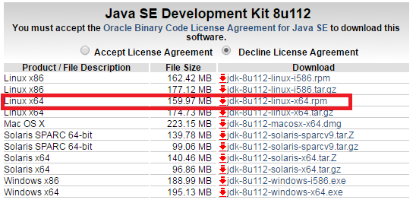

rpm -ivh jdk-8u112-linux-x64.rpm

**Oracle WebLogic Server 12c (12.2.1)**

Version: Fusion Middleware Infrastructure Installer

Quicker or Generic version are not work when install monitor.

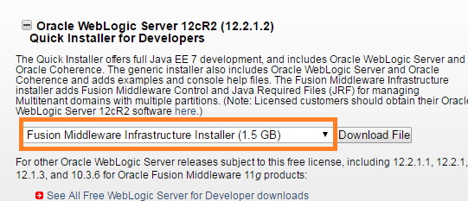

fmw_12.2.1.2.0_infrastructure_Disk1_1of1.zip

unzip fmw_12.2.1.2.0_infrastructure_Disk1_1of1.zip

sjprgldngtmon01 [oracle] > ls -lt

total 3053068

-rw-r--r-- 1 oracle oinstall 1563100157 Nov 28 14:11 fmw_12.2.1.2.0_infrastructure_Disk1_1of1.zip

-rw-r--r-- 1 oracle oinstall 8986 Oct 11 14:55 fmw_12212_readme.htm

-r-xr-xr-x 1 oracle oinstall 1563217124 Oct 9 21:49 fmw_12.2.1.2.0_infrastructure.jar*

**Oracle GoldenGate Monitor**

<http://www.oracle.com/technetwork/middleware/goldengate/downloads/index.html>

Oracle GoldenGate Monitor 12.2.1.2.0(425 MB)

fmw_12.2.1.2.0_ogg_Disk1_1of1.zip

unzip fmw_12.2.1.2.0_ogg_Disk1_1of1.zip

sjprgldngtmon01 [oracle] > ls -lt

total 435580

-r-xr-xr-x 1 oracle oinstall 446021430 Oct 11 18:46 fmw_12.2.1.2.0_ogg.jar*

-rw-r--r-- 1 oracle oinstall 8986 Oct 11 14:55 fmw_12212_readme.htm

# Step2 Install Oracle WebLogic Server 12c (12.2.1)

Use NoMachine client and use oracle account

mkdir -p /u01/app/oraInventory

java -jar fmw_12.2.1.2.0_infrastructure.jar

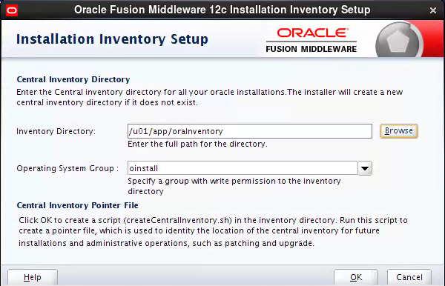

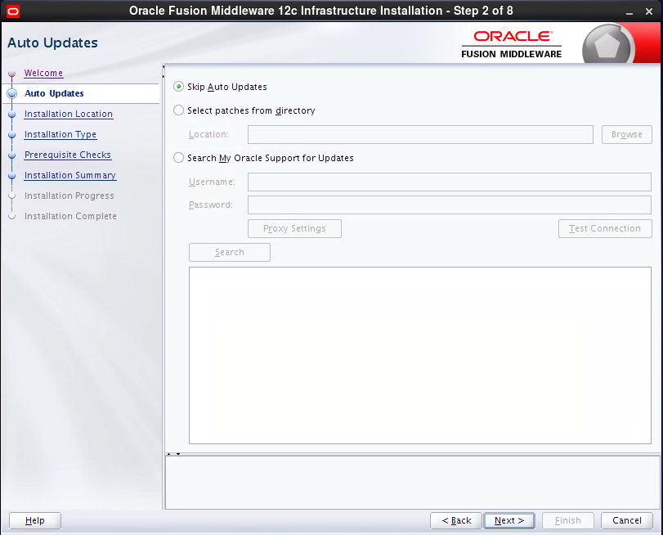

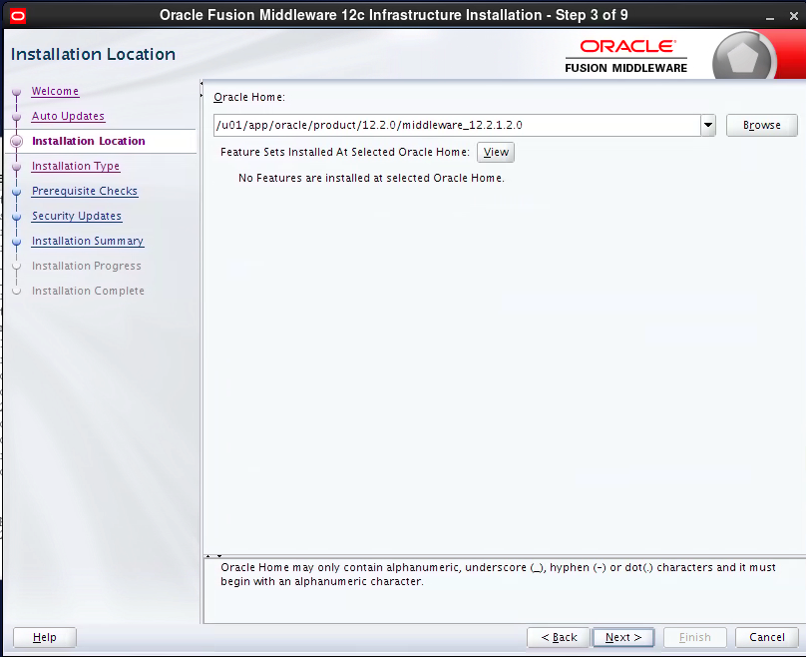

/u01/app/oracle/product/12.2.0/middleware_12.2.1.2.0

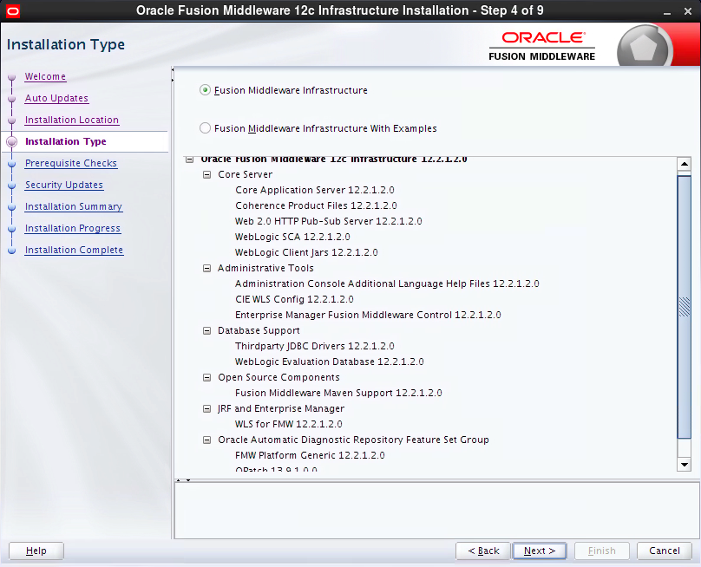

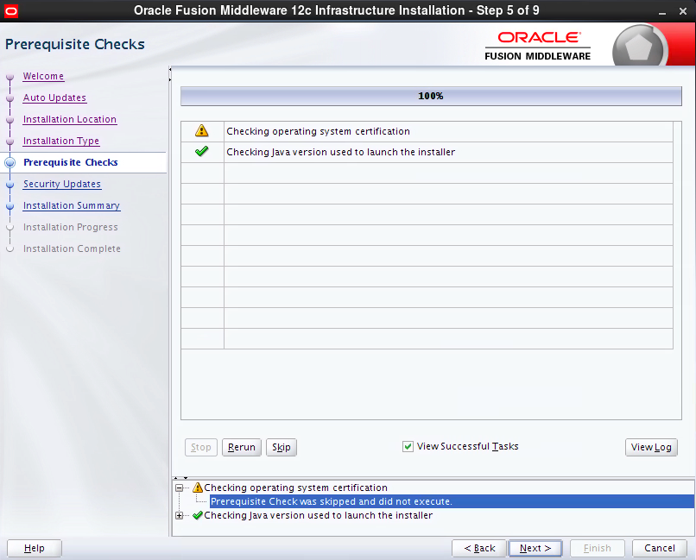

Skip

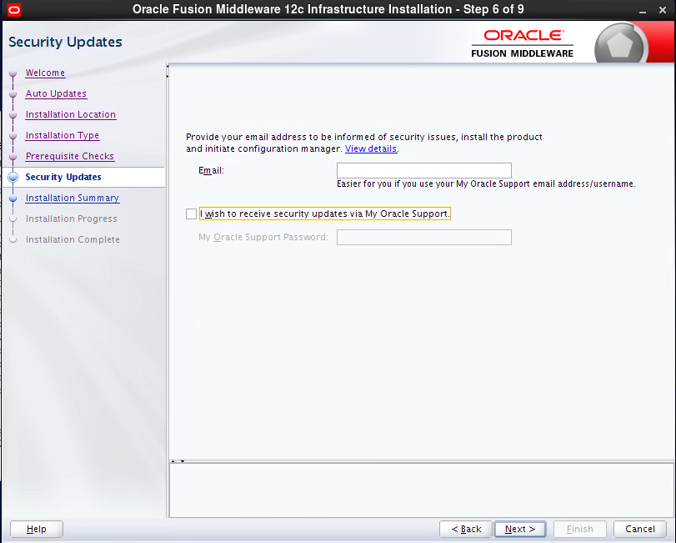

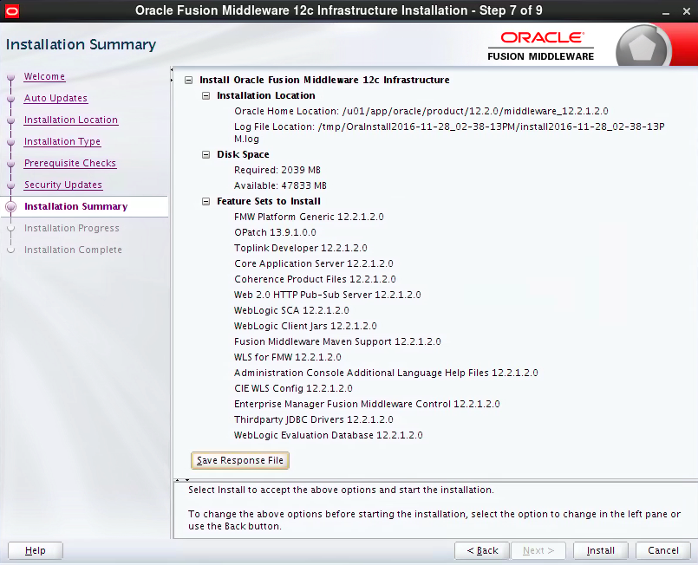

14:50

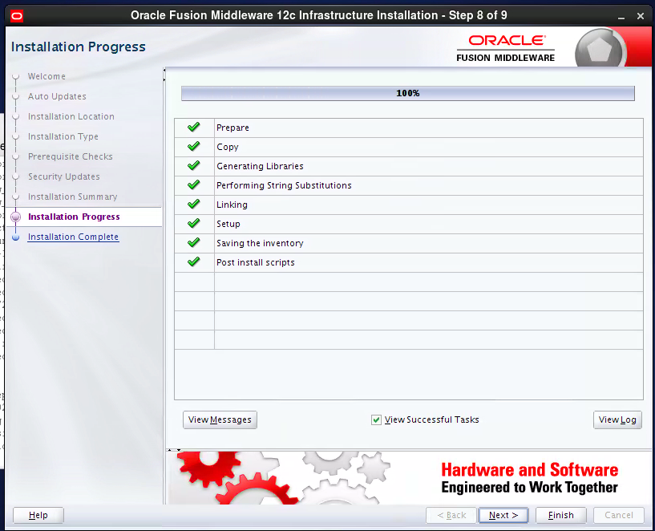

14:57

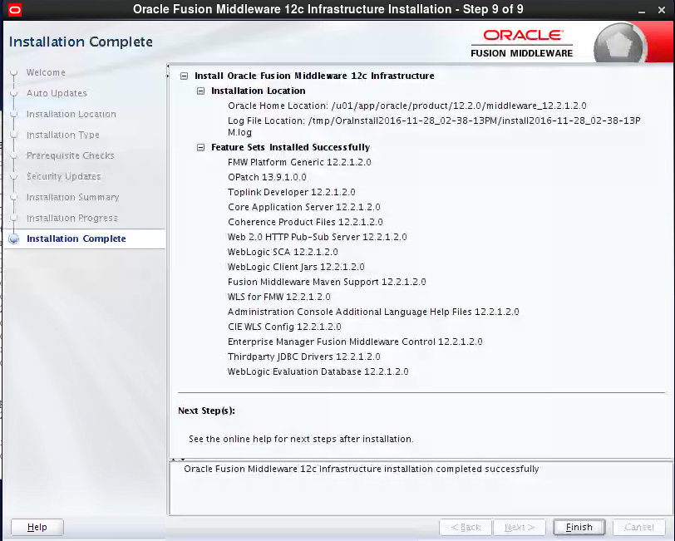

# Step3 Install Oracle Goldengate Monitor:

java -jar -Xmx1024m fmw_12.2.1.2.0_ogg.jar

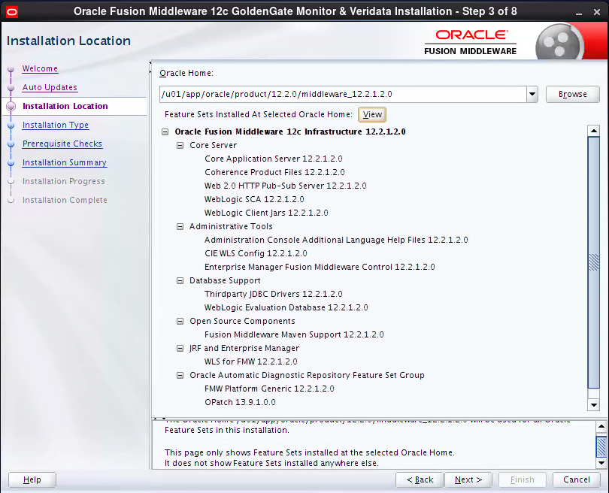

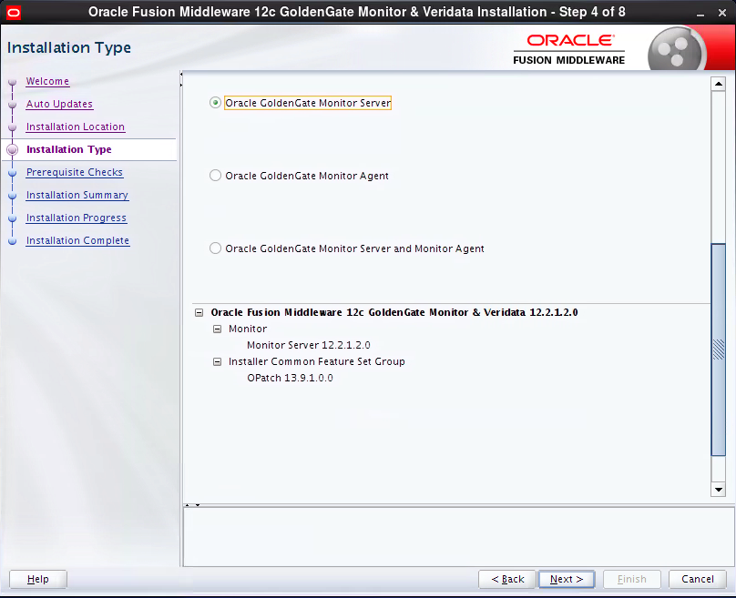

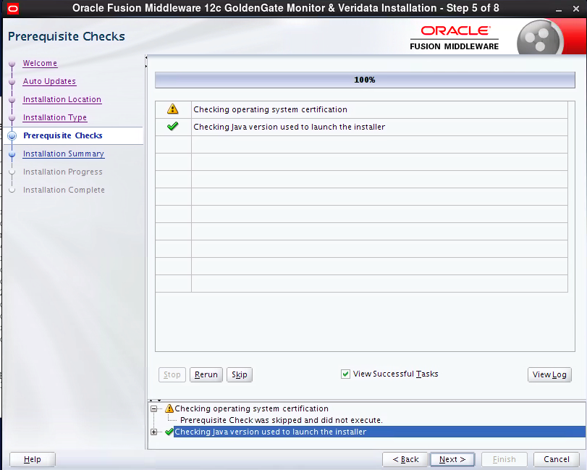

Skip

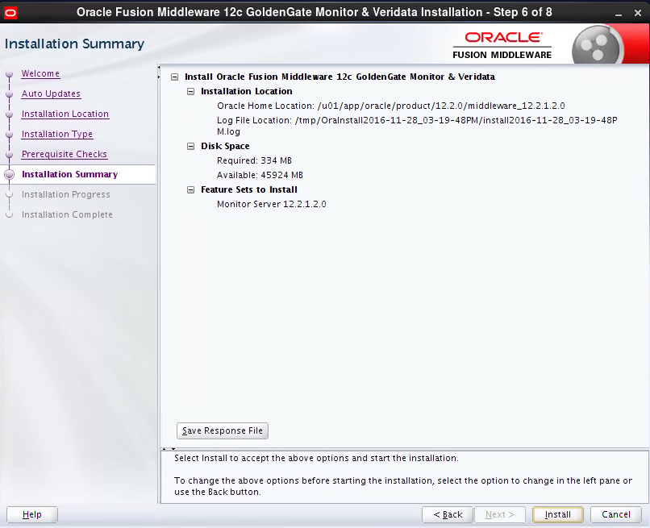

15:22

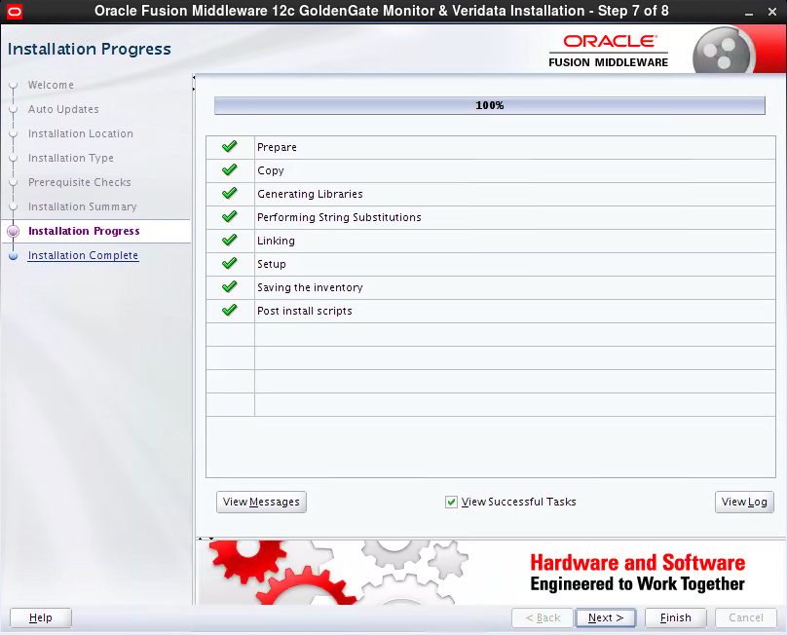

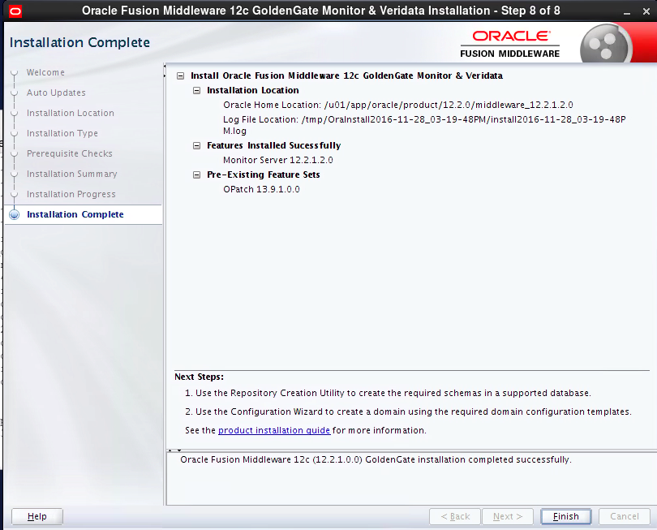

# Step4 Creating a Repository

**$ORACLE_HOME/oracle_common/bin**

**./rcu**

**Drop first if already created:**

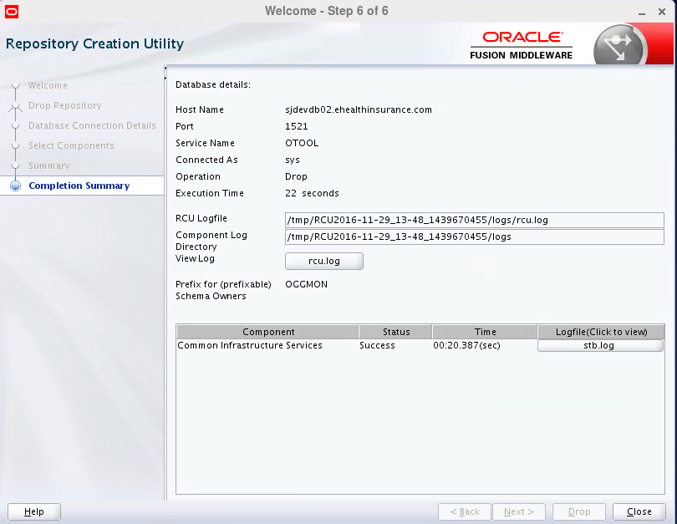

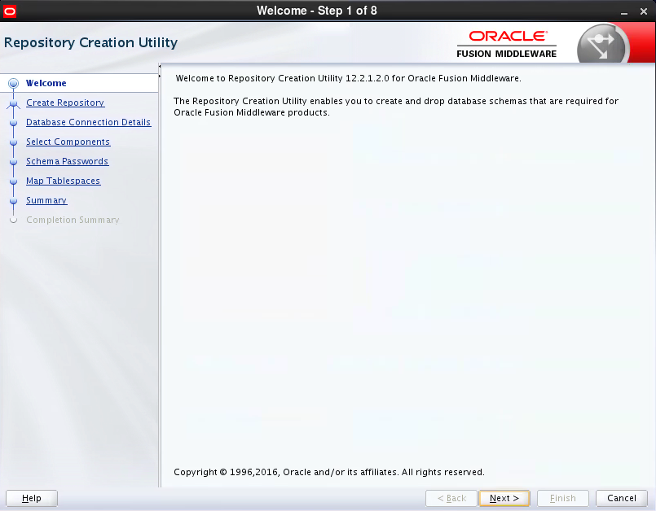

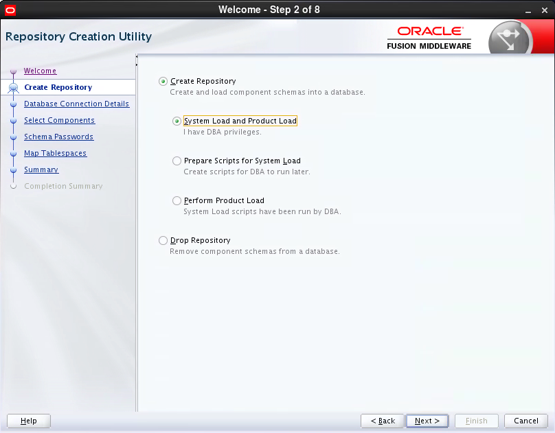

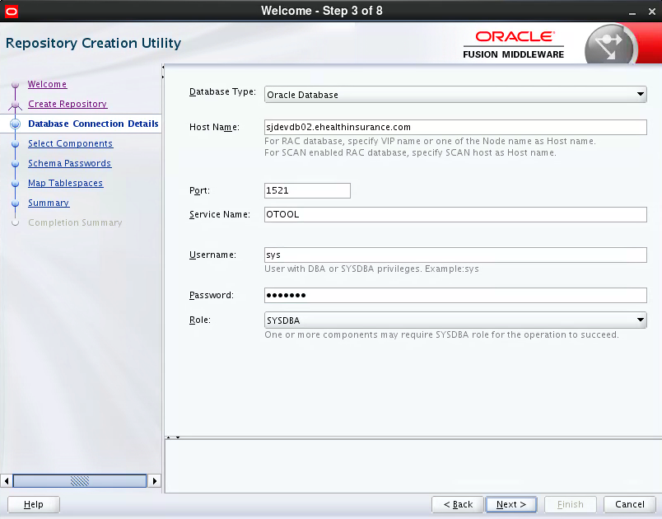

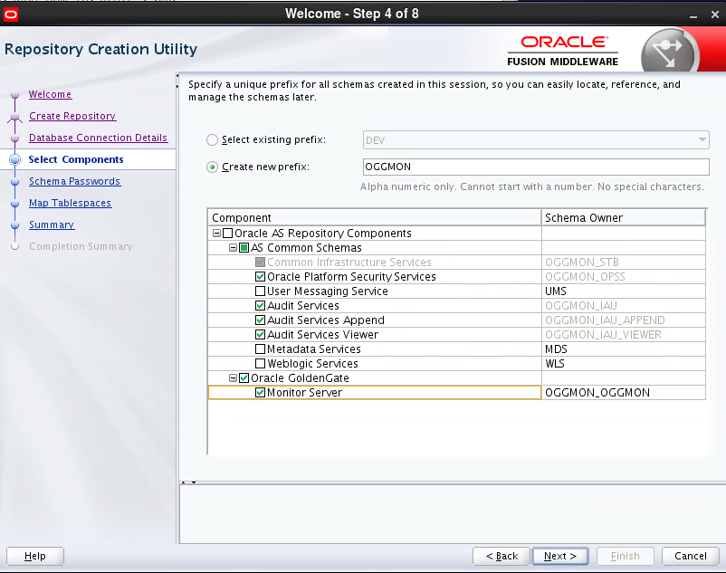

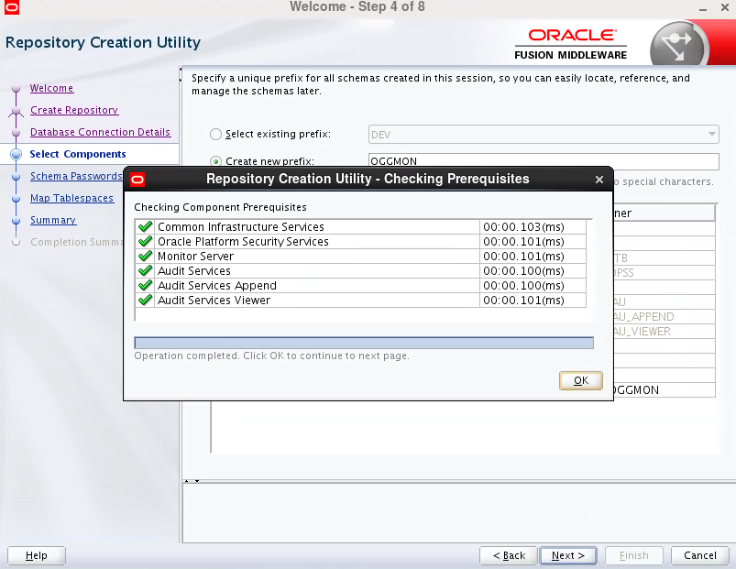

oggmon/XXXXXXXXXXXXX

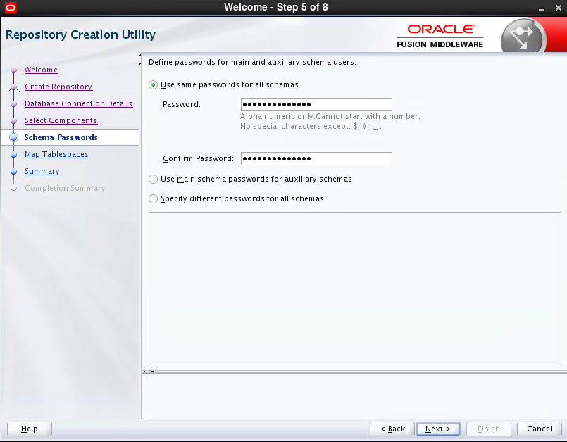

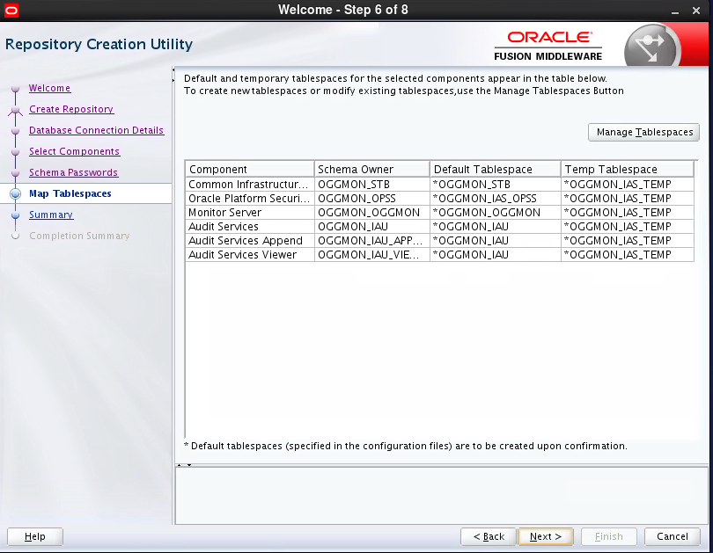

create below accounts in db OTOOLS on sjdevdb02:

OGGMON_OGGMON

OGGMON_STB

OGGMON_IAU_APPEND

OGGMON_OPSS

OGGMON_IAU_VIEWER

OGGMON_IAU

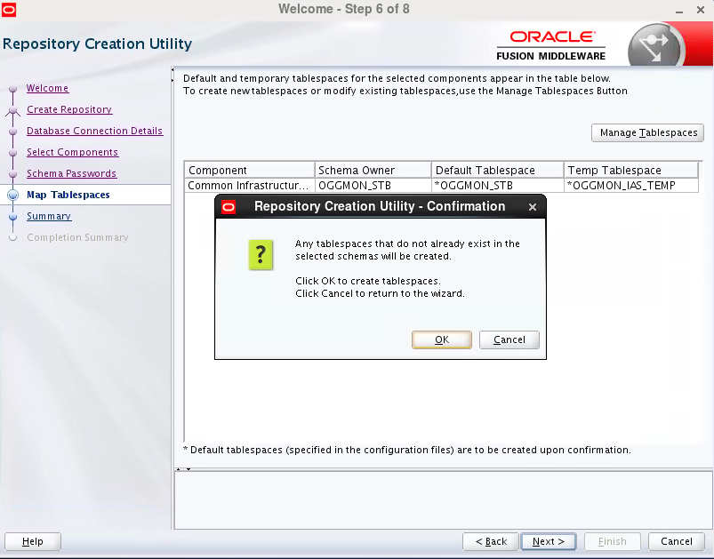

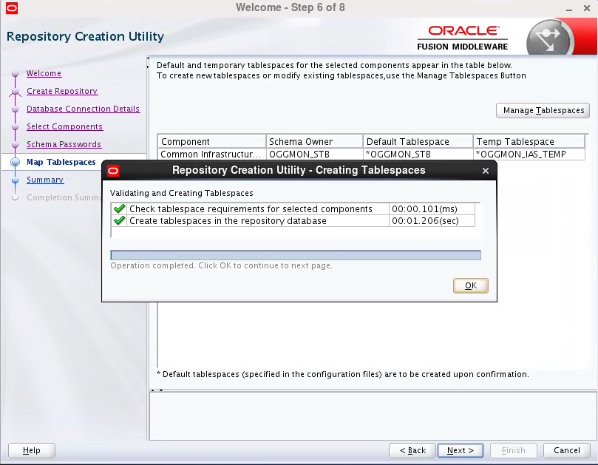

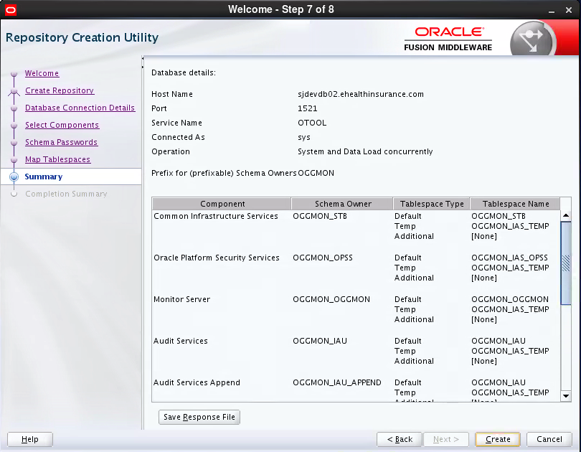

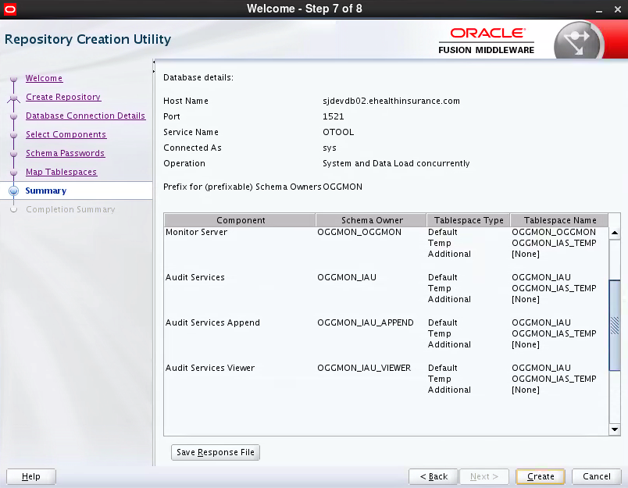

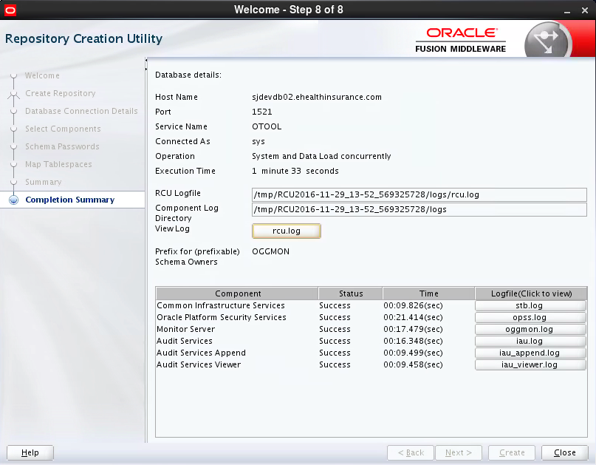

# Step5 Configure domain

$ORACLE_HOME/oracle_common/common/bin/config.sh

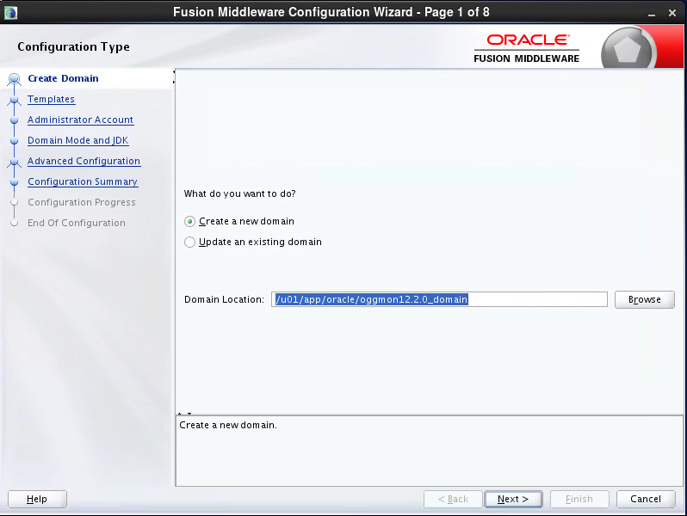

/u01/app/oracle/oggmon12.2.0_domain

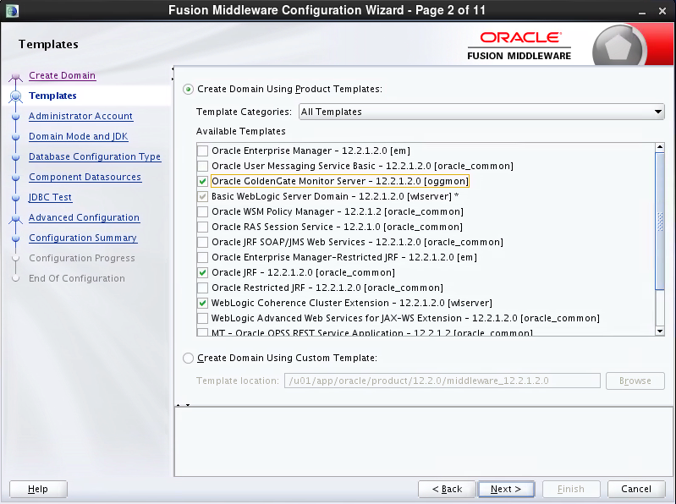

14:04~

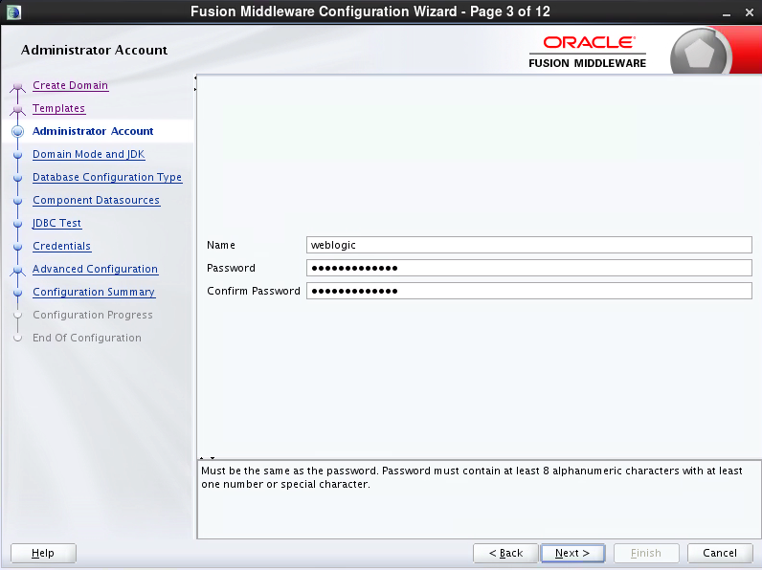

weblogic

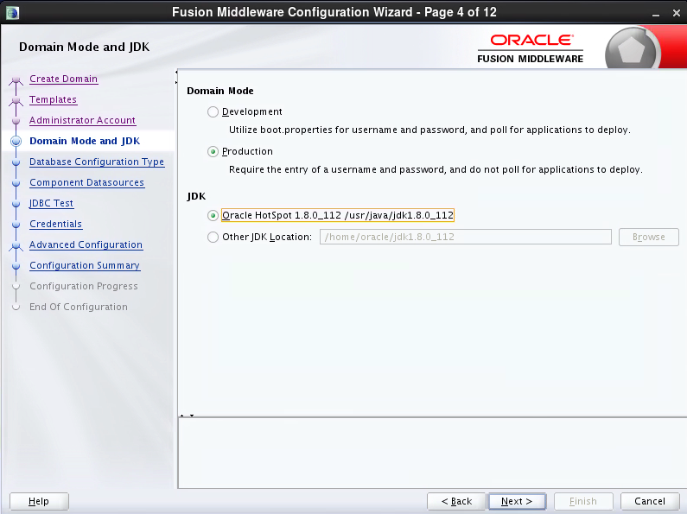

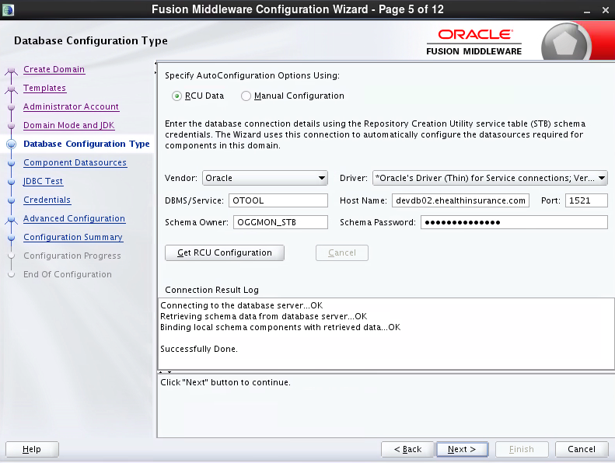

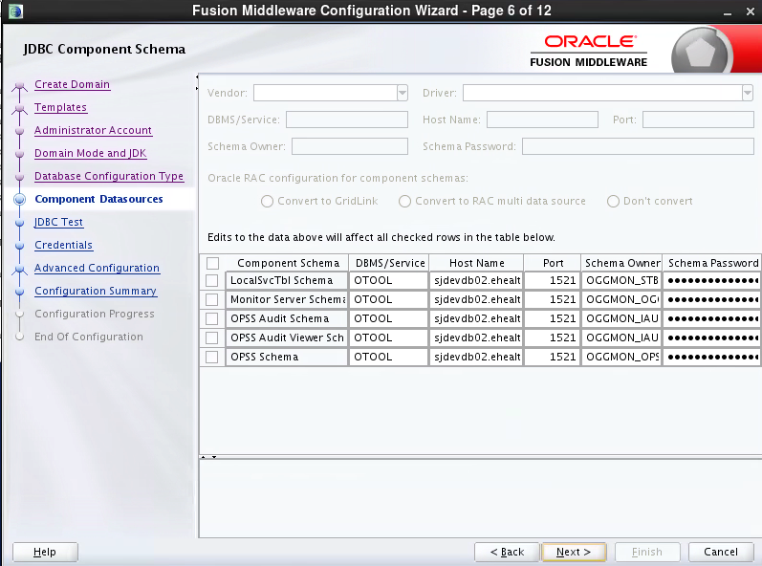

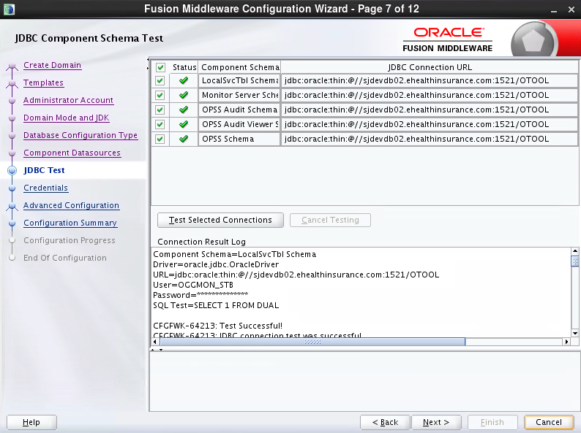

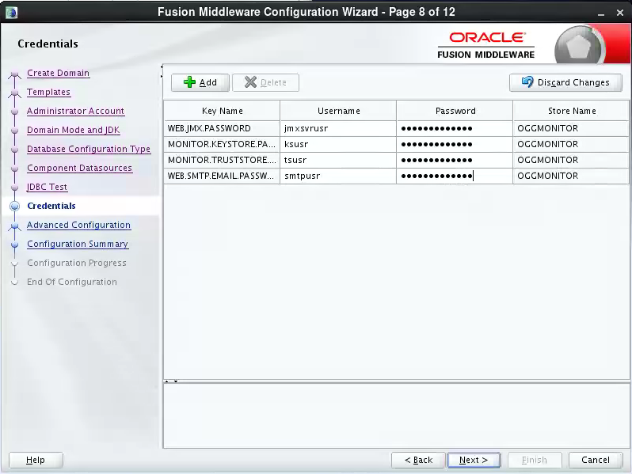

Jmxsvrusr(We changed this username to oggmsjmxusr, please use oggmsjmxusr)

ksusr

tsusr

smtpusr

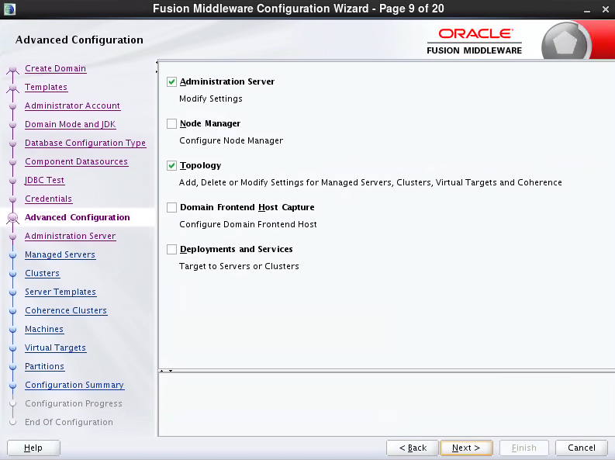

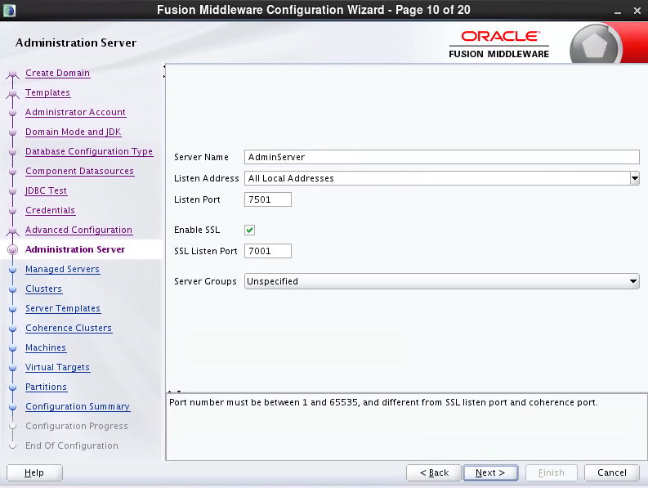

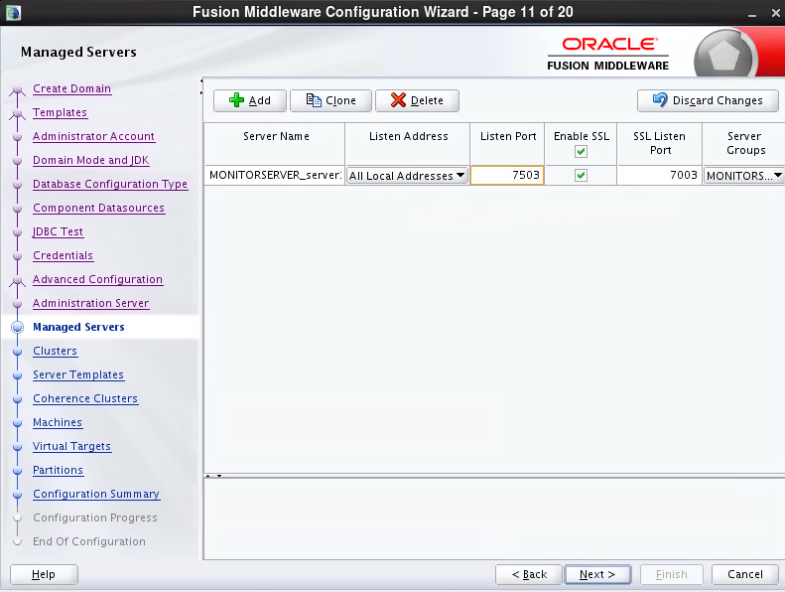

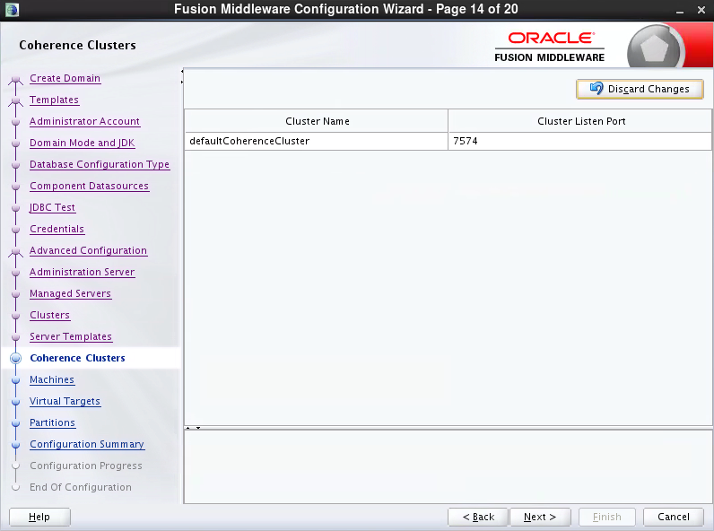

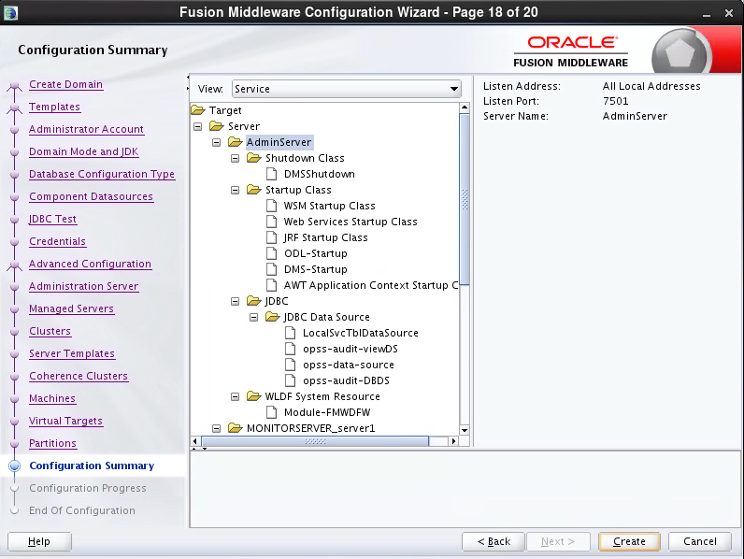

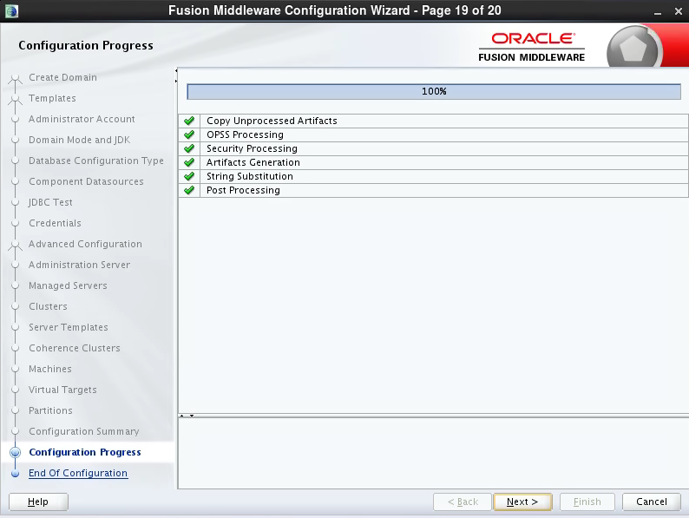

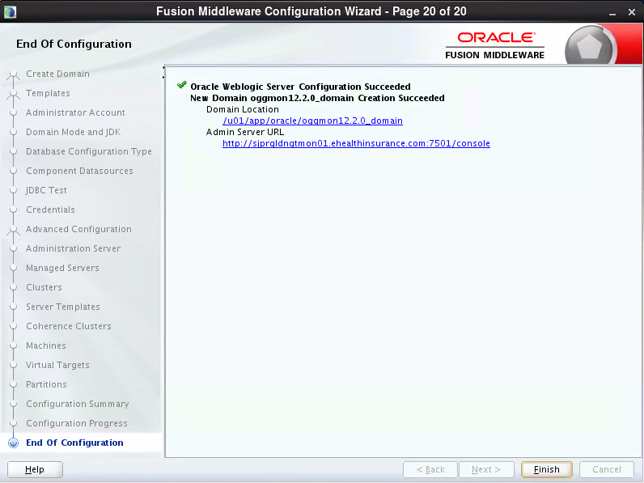

# Step6 Create oggadmin account:

**https://sjprgldngtmon01:7001/console**

**weblogic/XXXXXXXXX**

2. Click -> Security Realms (menu on left of the page)

3. Click -> myrealm

4. Click -> Users and Groups tab

5. Click -> New (user) button

6. Enter Name, Description, Password and Confirm Password fields

Click -> OK button

7. Click on top of the newly created [user]

8. Click Groups tab

9. Select/Move all Parent Groups Available

Click -> Save

**https://sjprgldngtmon01:7003/monitor/faces/loginPage.jspx**

**oggadmin/XXXXXX**

# Step7 Configure start and stop Admin server and Monitor server without password:

Stop Admin server and monitor server:

cd /u01/app/oracle/oggmon12.2.0_domain/bin

./stopManagedWebLogic.sh MONITORSERVER_server1

./stopWebLogic.sh

Create boot.properties files

As oracle account:

mkdir -p /u01/app/oracle/oggmon12.2.0_domain/servers/AdminServer/security

cd /u01/app/oracle/oggmon12.2.0_domain/servers/AdminServer/security

vi boot.properties

username=weblogic

password=XXXXXXXXXX

mkdir -p /u01/app/oracle/oggmon12.2.0_domain/servers/MONITORSERVER_server1/security

cd /u01/app/oracle/oggmon12.2.0_domain/servers/MONITORSERVER_server1/security

vi boot.properties

username=weblogic

password=XXXXXXXXXX

Start Admin server and monitor server(About 20 minutes):

cd /u01/app/oracle/oggmon12.2.0_domain/bin

./startWebLogic.sh >>/u01/app/oracle/report/startWebLogic.log 2>&1 &

./startManagedWebLogic.sh startManagedWebLogic.sh MONITORSERVER_server1 https://sjprgldngtmon01:7001 >>/u01/app/oracle/report/startManagedWebLogic.log 2>&1 &

# Step8 Configure start and stop Admin server and Monitor server script:

#As oracle account:

mkdir -p /u01/app/oracle/report

touch startWebLogic.log

touch startManagedWebLogic.log

#As root:

vi /etc/init.d/oggmonitor:

#!/bin/bash

#

# oracle Init file for starting and stopping WLS

#

# chkconfig: 35 80 30

# description: Oracle WLS startup script

# Source function library

. /etc/rc.d/init.d/functions

ORACLE_OWNER="oracle"

DOMAIN_HOME="/u01/app/oracle/oggmon12.2.0_domain"

case "$1" in

start)

v_adminport_count=`netstat -ant|grep LISTEN|grep -c 7001`

v_monitorport_count=`netstat -ant|grep LISTEN|grep -c 7003`

if [[ $v_adminport_count -gt 0 ]] ; then

echo "Port 7001 already exist! Start failed!"

exit -1

fi

if [[ $v_monitorport_count -gt 0 ]] ; then

echo "Port 7003 already exist! Start failed!"

exit -1

fi

echo $"Starting Weblogic Admin Server at `date '+%Y_%m_%d_%H%M%S'`:"

echo $"Starting Weblogic Admin Server at `date '+%Y_%m_%d_%H%M%S'`:" >>/u01/app/oracle/report/startWebLogic.log

su - $ORACLE_OWNER -c "$DOMAIN_HOME/bin/startWebLogic.sh >>/u01/app/oracle/report/startWebLogic.log 2>&1 &"

echo "please check log :$DOMAIN_HOME/servers/AdminServer/logs/AdminServer.log"

echo "Checking if Weblogic Admin Server is started......."

echo "Checking port 7001......."

v_adminport_count=`netstat -ant|grep LISTEN|grep -c 7001`

while [[ $v_adminport_count -lt 1 ]]

do

echo "Port 7001 is not be listened, sleep 60s then checking port 7001......."

sleep 60s

v_adminport_count=`netstat -ant|grep LISTEN|grep -c 7001`

done

echo "Starting Weblogic Oracle Goldengate Monitor Managed Server1 at `date '+%Y_%m_%d_%H%M%S'`:"

echo "Starting Weblogic Oracle Goldengate Monitor Managed Server1 at `date '+%Y_%m_%d_%H%M%S'`:" >>/u01/app/oracle/report/startManagedWebLogic.log

#su - $ORACLE_OWNER -c "$DOMAIN_HOME/bin/startManagedWebLogic.sh MONITORSERVER_server1 https://sjprgldngtmon01:7001 >/dev/null 2>&1 &"

su - $ORACLE_OWNER -c "$DOMAIN_HOME/bin/startManagedWebLogic.sh MONITORSERVER_server1 https://sjprgldngtmon01:7001 >>/u01/app/oracle/report/startManagedWebLogic.log 2>&1 &"

echo "please check log :$DOMAIN_HOME/servers/MONITORSERVER_server1/logs/MONITORSERVER_server1.log"

v_monitorport_count=`netstat -ant|grep LISTEN|grep -c 7003`

while [[ $v_monitorport_count -lt 1 ]]

do

echo "Port 7003 is not be listened, sleep 60s then checking port 7003......."

sleep 60s

v_monitorport_count=`netstat -ant|grep LISTEN|grep -c 7003`

done

echo "OK at `date '+%Y_%m_%d_%H%M%S'`!"

;;

stop)

echo $"Stopping Weblogic Oracle Goldengate Monitor Managed Server1:"

su - $ORACLE_OWNER -c "$DOMAIN_HOME/bin/stopManagedWebLogic.sh MONITORSERVER_server1"

echo $"Stopping Weblogic Admin Server:"

su - $ORACLE_OWNER -c "$DOMAIN_HOME/bin/stopWebLogic.sh"

echo "OK"

;;

*)

echo $"Usage: $0 {start|stop}"

esac

As root:

Start Admin server and Monitor server(Need about 20 minutes):

service oggmonitor start

Stop Admin server and Monitor server:

service oggmonitor stop

**It takes too long time to start up, we do not add to auto start service.**

# Step9 Completing Monitor Server Configuration

cd /u01/app/oracle/product/12.2.0/middleware_12.2.1.2.0/oggmon/monitor_server/bin

./updateOGGMonitorConfig.sh

# Enter the absolute path for your Oracle GoldenGate Monitor Server (oggmon) domain:

/u01/app/oracle/oggmon12.2.0_domain

# Enter your JMX hostname or IP address:

sjprgldngtmon01.ehealthinsurance.com

# Enter your JMX Server Port:

5502

# Enter your JMX Server Username.

oggmsjmxusr

# Enter the database type for your Oracle GoldenGate Monitor Server using 1 for Oracle Database and 2 for SQL Server.

1

#The utility completes. After successful execution of this script, the Secure Key properties file, oggmon.properties, is created in encoded format, and contains all of the configuration information you just provided. This Secure Key is added to your Oracle GoldenGate Monitor Server Oracle wallet.

# Copy the oggmon.properties file to the cfg directory of your Oracle GoldenGate Monitor Agent instance. For Oracle GoldenGate Monitor Server, the directory is MonitorServer_WLS_Domain/config/monitorserver/cfg; for Monitor Agent, the directory is MonitorAgent_Instance_Home/cfg.

For the monitor server configure files, please check:

/u01/app/oracle/oggmon12.2.0_domain/config/monitorserver/cfg/monitor.properties

Stop monitor server and admin server:

As root: service oggmonitor stop

Start admin server and monitor server(About 20 minutes):

As root: service oggmonitor start

# Step10 Configure agent:

##########https://docs.oracle.com/goldengate/m1221/gg-monitor/GGAIN/GGAIN.pdf

##########2.2.3.1 Creating an Oracle GoldenGate Monitor Wallet

##########1.Delete any existing dirwlt directory.

##########2.Ensure that the oggmon.properties file is copied into the cfg directory.

##########3.Start creating the wallet credentials:

##########For this Operating System

##########Use this command

##########Unix

##########$ ./pw_agent_util.sh –create

Stop Agent:

ggsci

info all

stop jagent

info all

Delete any existing dirwlt directory.

rm –rf /u02/app/oracle/oggagent_inst/dirwlt

# Copy the oggmon.properties file to the cfg directory of your Oracle GoldenGate Monitor Agent instance.

Monitor server on sjprgldngtmon01: /u01/app/oracle/oggmon12.2.0_domain/config/monitorserver/cfg/oggmon.properties

Copy to sjdevdb06 and sjqadb04:

/u02/app/oracle/oggagent_inst/cfg/oggmon.properties

Start creating the wallet credentials:

sjdevdb06 DEV4 > cd /u02/app/oracle/oggagent_inst/bin

sjdevdb06 DEV4 > ./pw_agent_util.sh -create

Please create a password for Java Agent:

Please confirm password for Java Agent:

Please enter Monitor Server JMX password:

Please confirm Monitor Server JMX password:

Nov 30, 2016 4:26:52 PM oracle.security.jps.JpsStartup start

INFO: Jps initializing.

Nov 30, 2016 4:26:52 PM oracle.security.jps.JpsStartup start

INFO: Jps started.

Wallet is created successfully.

Start Agent:

ggsci

info all

start jagent

info all

check log to make sure no error message in: /u02/app/oracle/oggagent_inst/logs/ogg_agent.log

# Step 11 SiteOps to configure monitor on the sjprgldngtmon01

SOPS-11935 Please configure monitor on sjprgldngtmon01.